2005 Natcar Preliminary Trials
UCLA, Bldg EIV
7 May
Two teams participated. The trial was attended by the IEEE Coastal L.A. Section Chairman Dr. Mike Briggs and Student Activities Chairman Steve Edlefsen (who took the pictures appearing below)
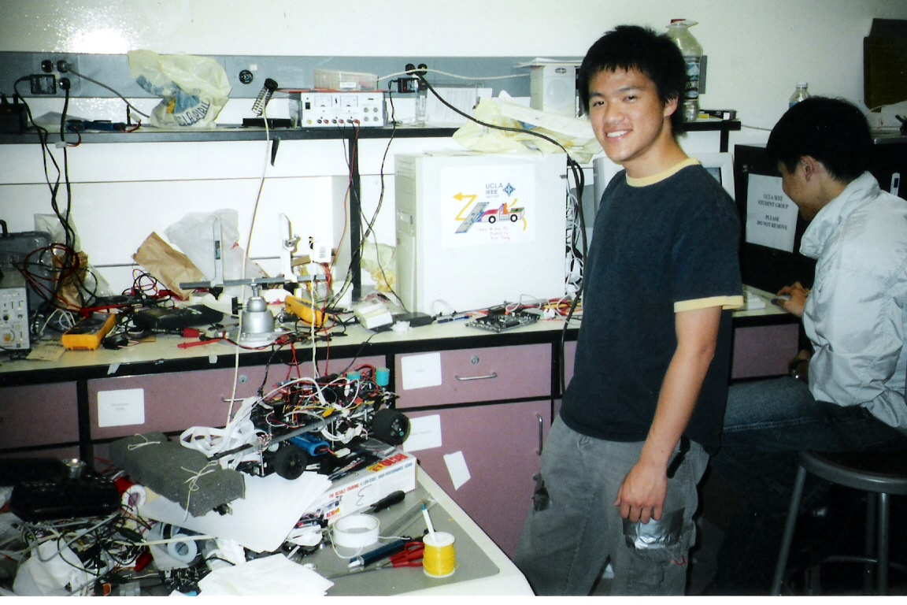
From left Mike Ma, Rick Huang and their natcar

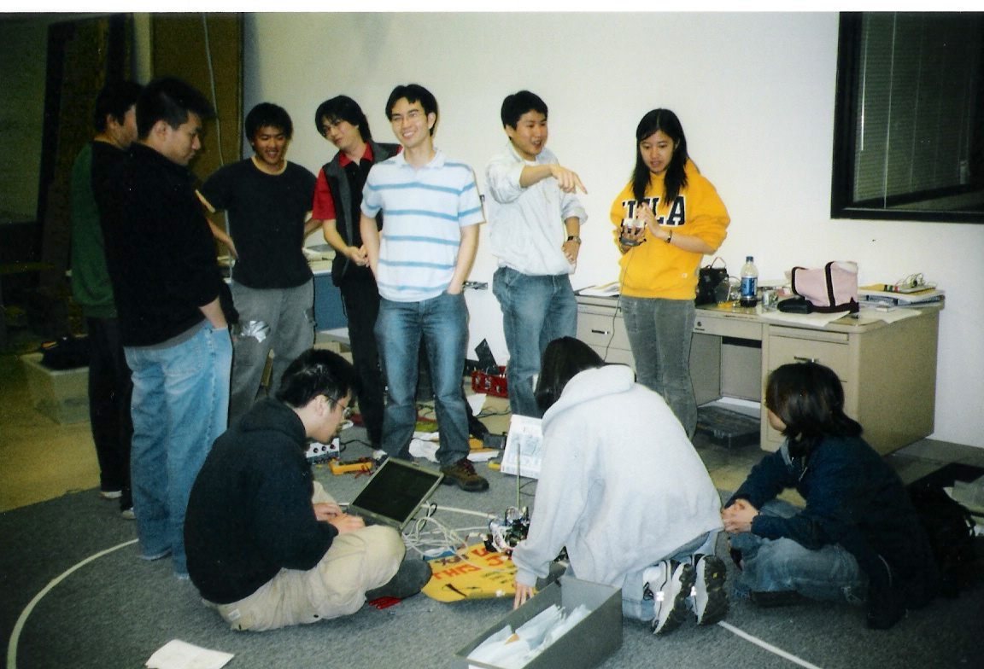
Standing from left: an unidentified observer, Wilson Chen, Mike Ma, Bernie Yip, Kevin Leung, Rick Huang, Ting Cui. Sitting from left: David Tung, Jennifer Yu and Kris Lin
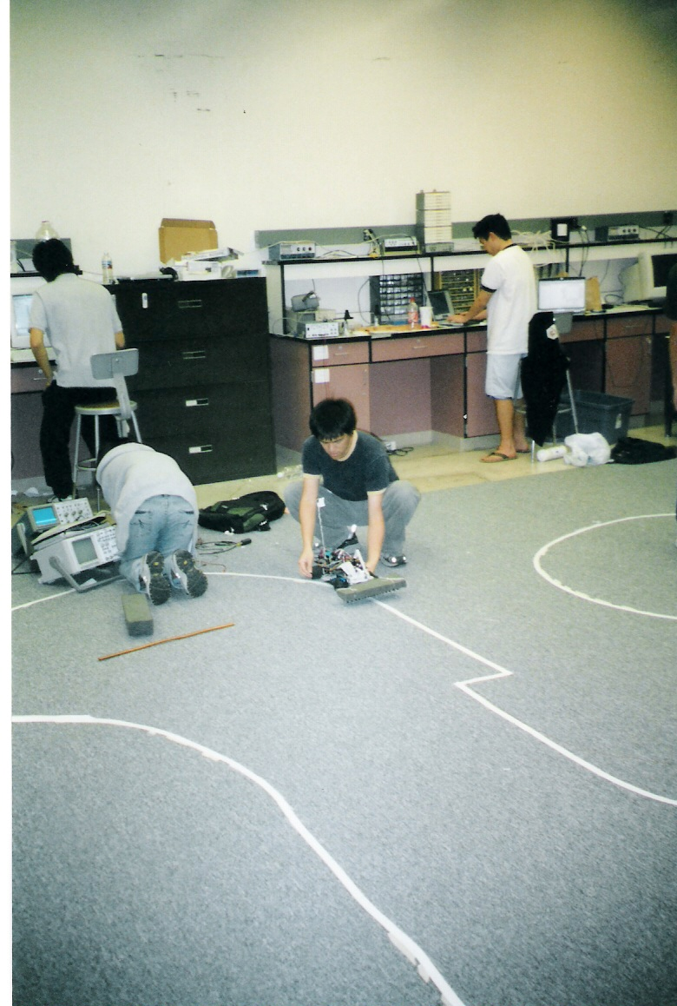

Steve Hsieh is sitting at the left while Mike Ma gets the natcar ready to roll. Stanley Hsu is standing at the right.
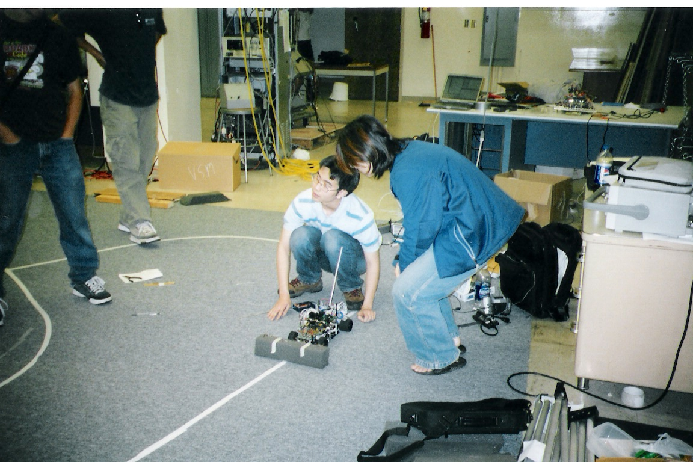
Kevin Leung and Kris Lin prepare for a test run.
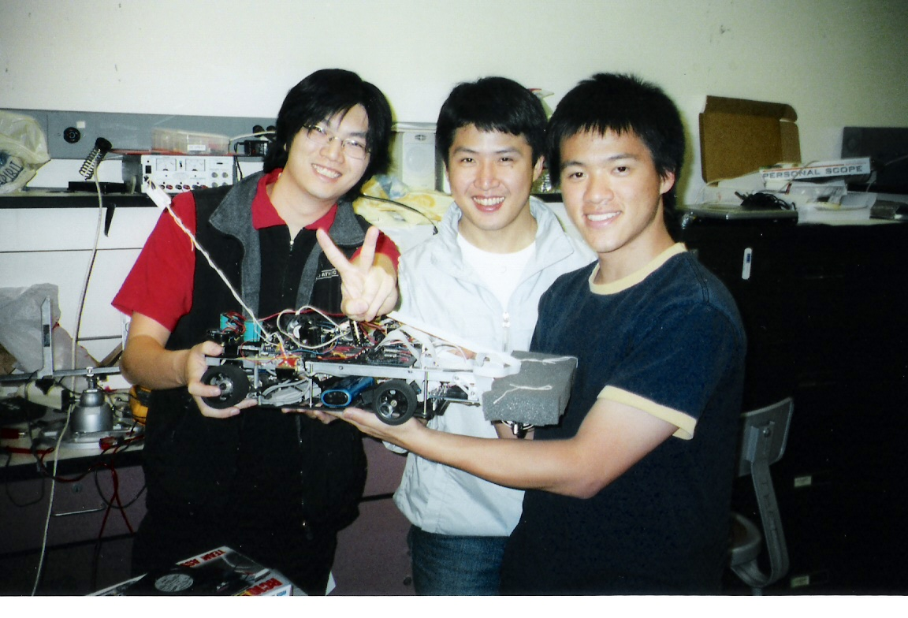
Team 3 (from left Bernie Yip, Rick Huang and Mike Ma)

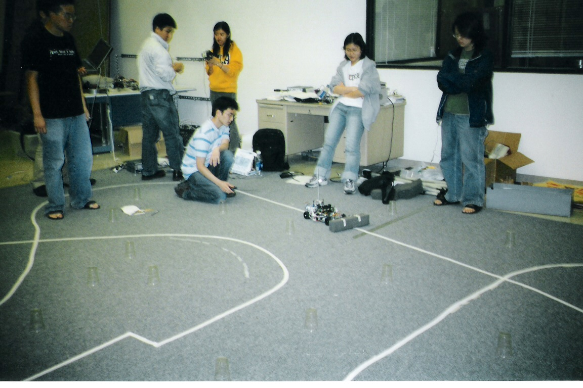
From left: David Tung (behind, with computer), Ainsley Chong, Rick Huang, Ting Cui Jennifer Yu and Kris Lin watch as Kevin Leung releases the natcar.
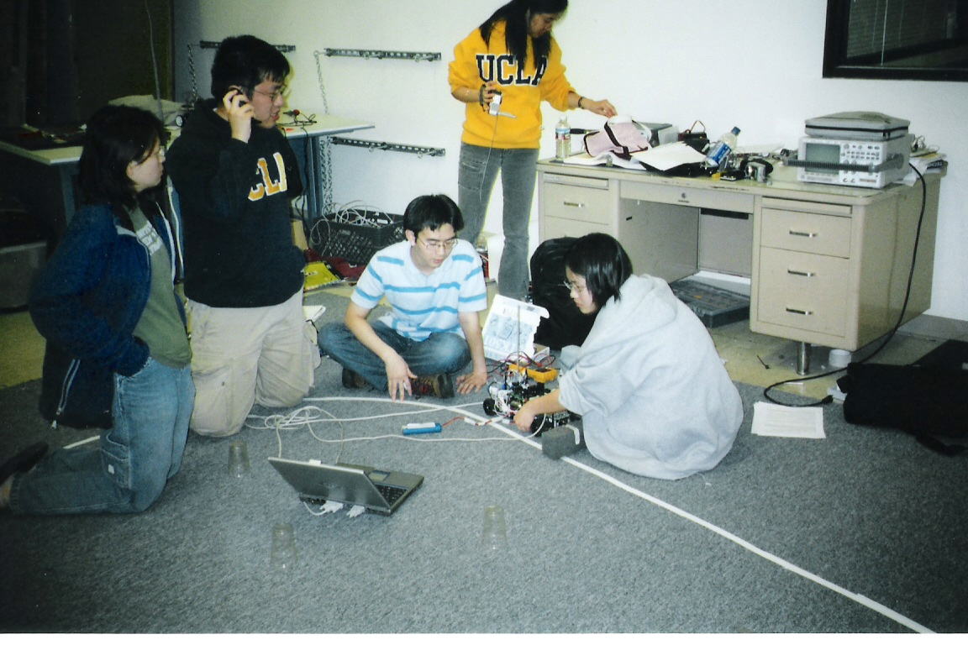
From left: Kris Lin, David Tung, Kevin Leung and Jennifer Yu make some last minute adjustments to the natcar. Ting Cui observes from behind.

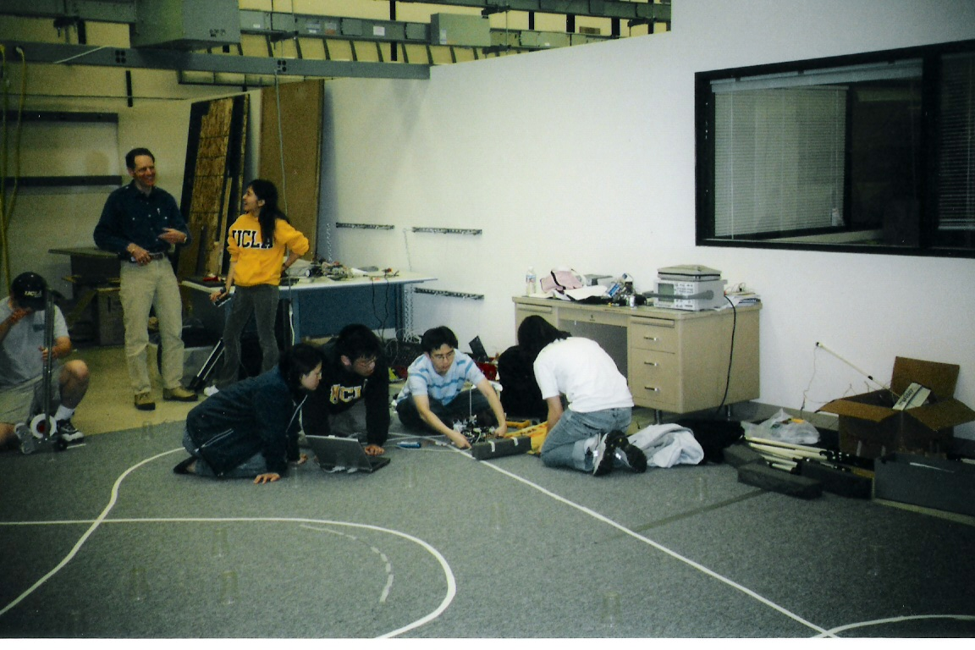
From left: Julian Sha, Dr. Mike Briggs, Ting Cui, Kris Lin, David Tung, Kevin Leung and Jennifer Yu.
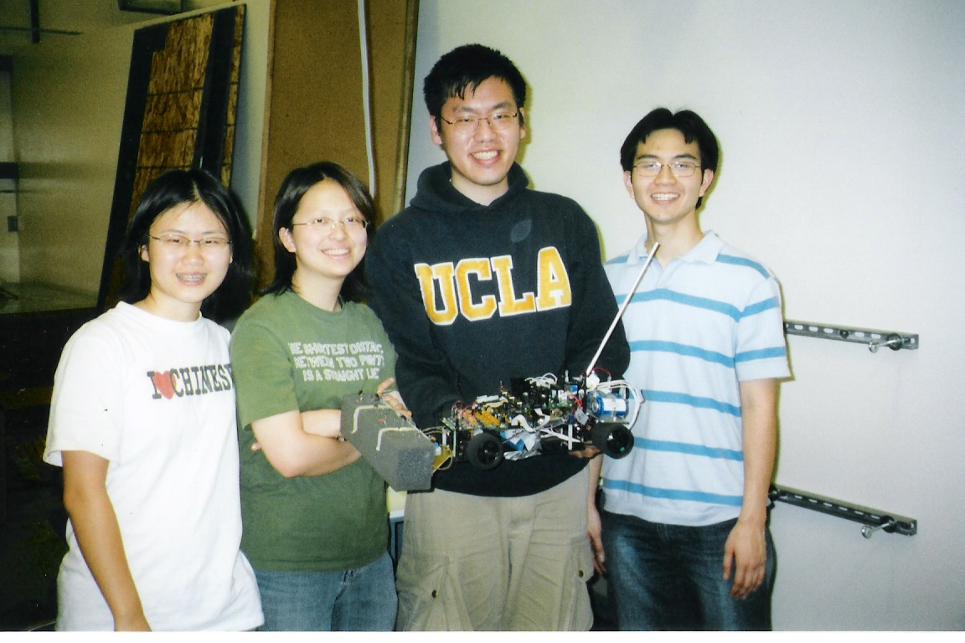
Team 1: Yingtzu Yu, Kris Lin, David Tung, Kevin Leung and their natcar.

